Control of Asbestos Regulations 2006
The Control of Asbestos Regulations came into force on 13 November 2006.
They bring together three previous sets of Regulations covering the prohibition of asbestos, the control of asbestos and asbestos licensing.
The Regulations prohibit the importation, supply and use of all forms of asbestos. They continue the ban introduced for blue and brown asbestos 1985 and for white asbestos in 1999. They also continue the ban on second-hand use of asbestos products such as asbestos cement sheets and asbestos boards and tiles; including panels which have been covered with paint or textured plaster containing asbestos.

REMEMBER: The ban applies to new use of asbestos. If existing asbestos materials are in good condition, they may be left in place, providing they are not disturbed.

The Regulations require mandatory training for anyone liable to be exposed to asbestos fibres at work. This includes

maintenance workers and others who may come into
contact with asbestos (eg cable installers) as well as those involved in asbestos removal work. When work which may disturb asbestos is being carried out, the Asbestos Regulations require employers to prevent exposure to asbestos fibres. Where this is not reasonably practicable, they must make sure that exposure is kept as low as reasonably practicable by measures other than the use of respiratory protective equipment. The spread of asbestos must be prevented. The Regulations specify the work methods and controls that should be used to prevent exposure and spread.
Worker exposure must be below the airborne exposure limit (Control Limit). The Asbestos Regulations have a single Control Limit for all types of asbestos of 0.1 fibres per cm3. A Control Limit is a maximum concentration of asbestos fibres in the air (averaged over any continuous 4 hour period) that must not be exceeded.
In addition, short term exposures must be strictly controlled and worker exposure should not

exceed 0.6 fibres per cm3 of air averaged over any continuous 10 minute period.
Respiratory protective equipment is an important part of the control regime but it must not be the sole measure used to reduce exposure and should only be used to supplement other measures. Work methods that control the release of fibres for non-licensed work should be used. Respiratory protective equipment must be suitable, must fit properly and must ensure that worker exposure is reduced as low as is reasonably practicable.
Anyone carrying out work on asbestos insulation, asbestos coating or asbestos insulating board (AIB) needs a licence issued by HSE unless they meet one of the exemptions for short duration low exposure work listed in the Regulations.
If the work is licensable:
- Notify the enforcing authority responsible for the site where you are working (for example HSE or the local authority)
- Designate the work area (see regulation 18 for details)
- Prepare specific asbestos emergency procedures; and
- Pay for your employees to undergo medical surveillance
The Asbestos Regulations require any analysis of the concentration of asbestos in the air to be measured in accordance with the 1997 WHO recommended method. From 6 April 2007, a clearance certificate for re-occupation may only be issued by a body accredited to do so. At the moment, such accreditation can only be provided by the United Kingdom Accreditation Service.

Photos Continuing the guilty photo series:

An overloaded adapter in a kitchen; both the microwave and the kettle consume lots of power; fire risk!

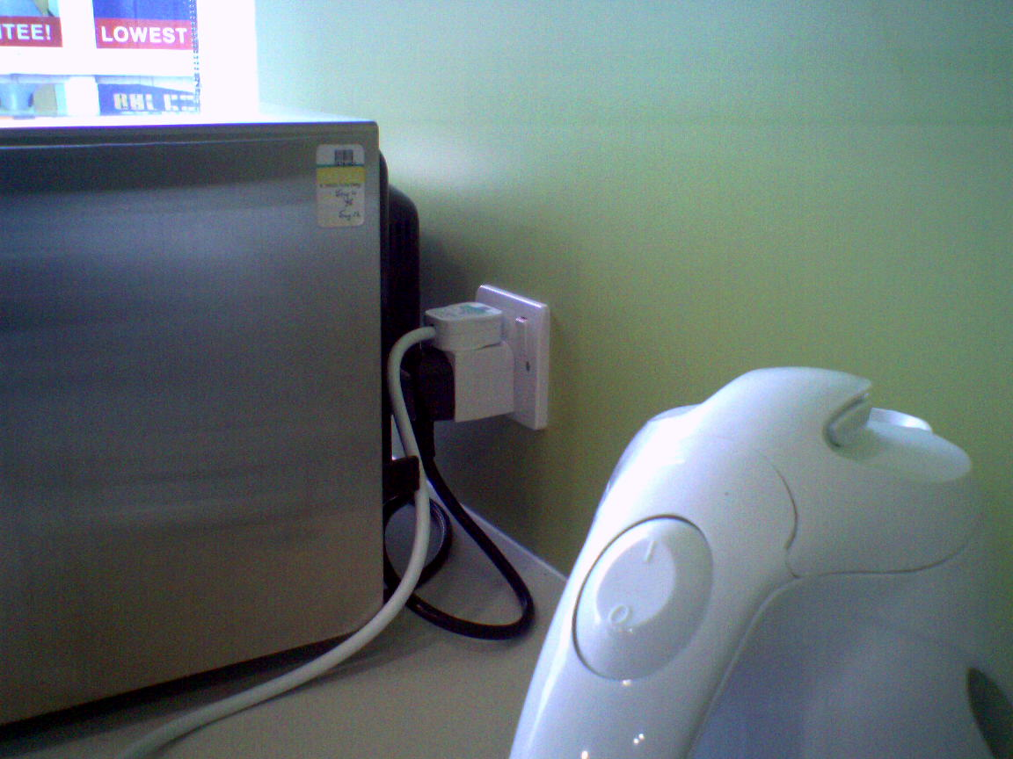

A permanently present cable across the entrance to a meeting room with the route used by lots of staff; this needs a permanent solution.
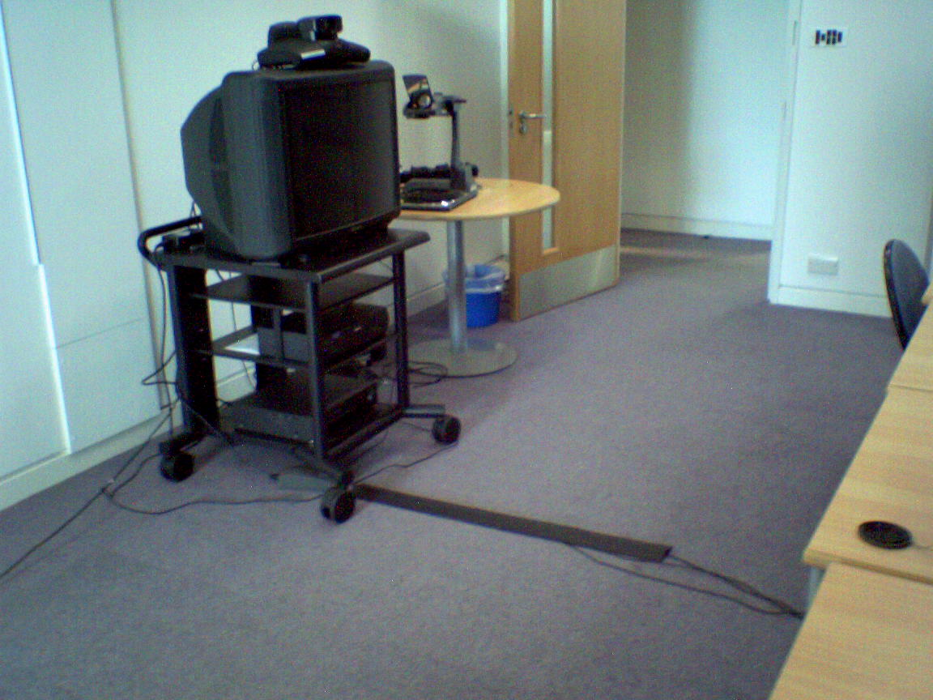

A loose carpet tile section at the top of the stairs; the worst place for a trip hazard!
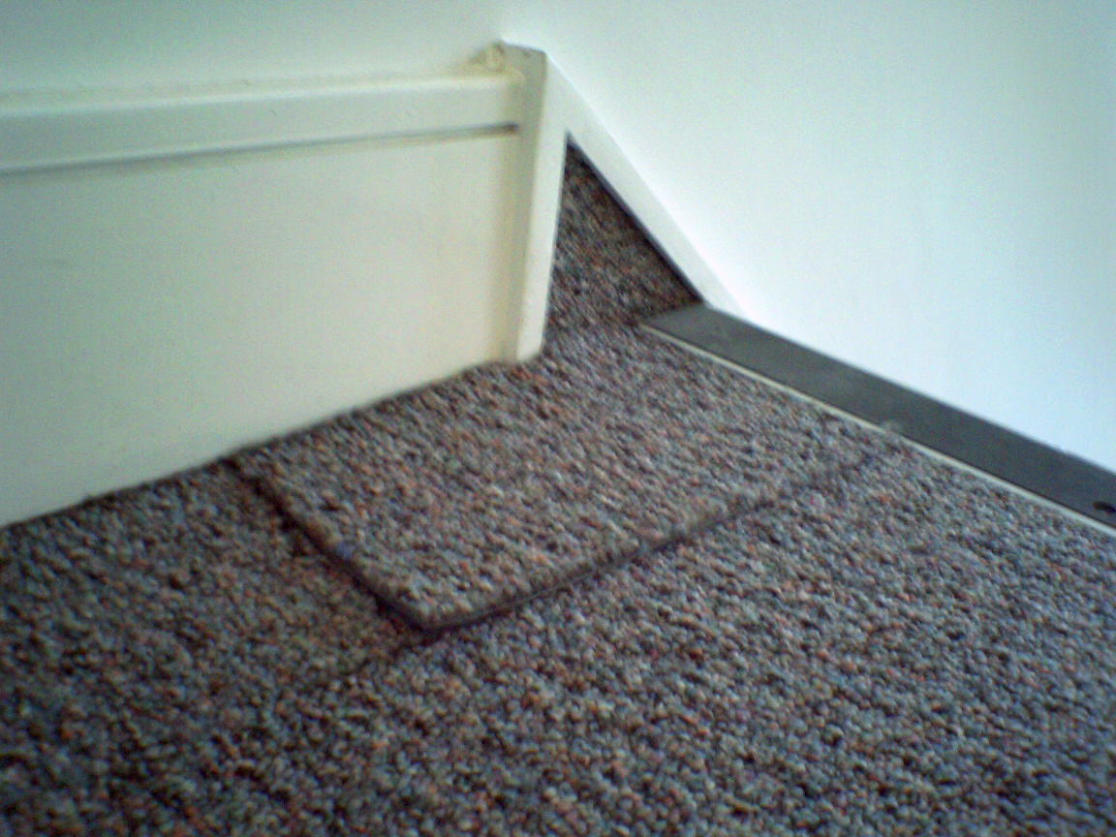

A purpose-built “safety station” holding policies briefings and guidance; Well Done!
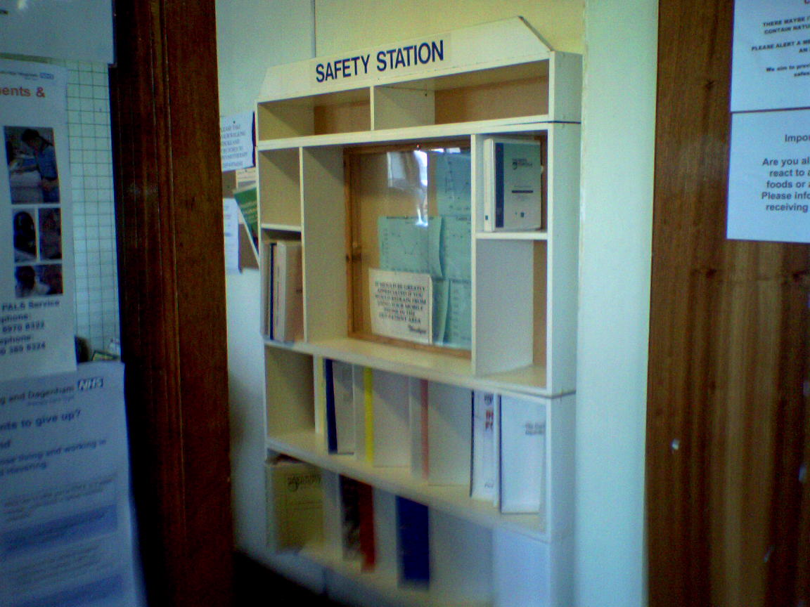

Buncefield Fuel Depot Fire
The depot contained over 35 million litres of fuel at the time of the fire last December. The latest report shows the chain of events;
- On Sunday 11th December 2005 Tank 912 was being filled with petrol.
- The level gauge showed no change but filling continued.
- Filling rate was a massive 550M³ per hour.
- At about 05:20 Tank 912 would have been completely full and started to overflow.
- At 05:38 a mist was reported by witnesses and caught on CCTV.
- At 05:46 a 2-metre deep heavy vapour cloud was flowing out of the containment bund.
- By 05:50 the vapour cloud started flowing offsite into local lanes and car parks.
- The pumping rate in the pipe rose to almost 900M³ per hour.
- At 06:01 the first explosion took place in a car park.
- 20 large tanks were engulfed in fire.
- Up to 190 fire fighters with 45 engines and support vehicles were present at the height of the fire.
- The “fire all out” was declared on Thursday 15th December.
- Evacuation of 2,000 people was necessary.
- Injured persons stood at 43 but thankfully minor.

The investigation continues to look for precise causes including faulty equipment and human error.

Wellness Advice for Employees
Here is a really quick A to Z list of advice, which could be used to promote workplace health. There are more ideas from the Health & Safety Executive, the “Charted Institution of Personnel & Development” and the Department of Health.

- Alcohol; consume less!
- Blood Pressure; get checked.
- Cigarettes; try to quit.
- Diabetes; get checked.
- Emotional and mental health; take care of it.
- Fat; cut the saturates.
- GUM Clinic; don’t go there, take precautions!
- Hydrogenated fats; cut these for your heart health and assess your risk of coronary heart disease.
- Inoculations; get the right vaccinations.
- Jog, swim or cycle; take some aerobic exercise and get out of breath!
- Kick the salt intake; try potassium chloride.
- Lifting; minimise and take care.
- Medicals; get your cholesterol and other vital factors checked.
- NHS Direct; discuss your health 24/7
- Office Bound? Move around more.
- Positive; be more optimistic!
- Quality of life; check your work-life balance.
- Relaxation; take some occasionally!
- Stress; take steps to eliminate.
- Therapies; explore complimentary types.
- Uncertain about health? See G.P now!
- Vegetables and fruit; eat five portions a day.
- Weight; check and lose some if needed.
- “X”ercise; be more physically active.
- Youth; preserve yours with a healthy lifestyle.
- ZZZZ; make sure you get enough sleep.

What have you done to help your staff stay healthy and be productive?

Pilot Flying Hours
The British Airline Pilots Association is concerned over the risks of increasing the maximum flying hours for pilots to 11¾ hours by night and 14 hours by day.

Research has shown that the accident risk is six times greater when the crew has worked for over 12 hours.

Safer Needle Systems
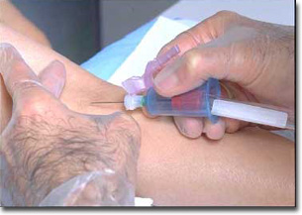

The European Parliament Social Affairs Committee is aiming to improve legislation to protect workers from the risk of needlestick accidents.
- Sharp implements cause puncture wounds or “needlesticks”.
- Medical, veterinary and laboratory staff most at risk.
- One million injuries per annum reported.
- Risk is from biological agents.
- Intrinsically safer needles are available.

- National legislation has made little impact on the problem.
- A new EC Directive is proposed.
One of our clients, an NHS Trust, introduced a safer needle system for all blood-taking hollow-bore needles in its two hospitals. The cost was only an extra £5,000 per annum. The benefits are enormous as body fluids can transmit up to twenty different infections.
Safety Inspections Down
Health and Safety Executive figures show that the number of inspections is down comparing the years 2003-2004 and 2004-2005.
The TUC union say that the inspection figures are a new low and that:
- Employers have a 1 in 40 chance of prosecution after a major accident.
- Health and Safety Executive inspectors are only likely to visit once every 13 years.
- Inspections are down by one quarter to 55,000 per year.

Thankfully most readers of this newsletter would not alter their approach following such reports, as

they know that good safety means good business!

Migrant Worker Safety
If you employ migrant workers take care over differences in language, culture and skill levels.
Problems might arise from;
- Understanding written material.
- Verbal understanding.
- Different interpretation.
- Risk accepting culture.
- Pressure to work if job loss would be critical to them.

To Control Stress Give Your Staff Control!
A Health & Safety Executive study reviewed how managing six key stress sources could benefit business. Of the six Factors; control, demand, support, relationships, role and change, it was found that where an employee has a significant say over the way that they do the work i.e. some “control”, this was a major factor in the management of occupational stress.

Prosecutions


Safety prosecutions for horrific accidents continue to fill the safety journals. The summaries below show figures for fines and costs added together for some recent health and safety prosecutions;

- Burns; Dumper truck driver engulfed in flames and died when a faulty truck turned over on a slope, spilling hot slag and diesel fuel (£142,000)

- Electrocution; Contractor electrocuted whilst trimming 22 feet high conifers close to an overhead power line when his long-handled loppers either touched the power line or received an arc through the air (£25,000)

- Road Accident; Driver fell asleep on his journey home after driving four 19-hour shifts. Chronic fatigue was due to work where long hours were documented (£54,000).

- Asbestos; Members of public exposed to asbestos when poorly briefed and supervised operative stripped bungalow roof tiles spreading dust over neighbour’s gardens (£38,000).

- Fall; Four building contractors suffered broken bones when they fell down a 22 feet deep lift shaft after unsuitable “putlog” scaffolding collapsed, (£41,000).

- Crushing; Surveyor crushed to death when he walked in a driver’s blind spot and was reversed over by the heavy machine (£44,000).

- Fall on level; Welsh Ambulance service and Cardiff and Vale NHS Trust left elderly mentally–infirm patent at wrong address after regular day-care unit visit: crew found key under mat and let her into someone else’s home; in confusion she fell in garden fracturing leg and later dying in hospital (£45,000).

- Fall; Chemical manufacture operative fell 3.6 metres through open trapdoor, leaving him paralyzed from the waist down (£55,000).

- Fall; Two workers seen painting on a fragile asbestos roof with no safety precautions (No injury: £5,000).

- Asbestos; Workers at risk of breathing asbestos fibres from damaged and poorly maintained insulation on pipes. No training given and staff had been told that the plant was safe (£136,000).

- Falling Object; Illegal asylum seeker working as construction site laborer pushed a 31 kg tub off scaffold onto a workmate’s head leaving him paraplegic and permanently on a ventilator (No fine for employer as careful checks made but false details given (worker given 180 hours community service).

- Fall; Builder stepped on loose steel floor plate falling 4 metres onto a concrete floor, before being hit by the falling plate causing fractures, internal & facial injuries resulted in nines days in ITU (£34,000).

- NHS Trust failed to control Legionnaires' disease
A Bristol inquest jury has returned a verdict that the

death from legionnaires' disease of an in-patient being treated at the Royal United Hospital, Bath, was caused by an absence of the appropriate precautions to manage the risk from legionella. investigation discovered the Trust had not implemented the proper procedures known to control the risk, such as flushing systems and cleaning shower heads, and its risk assessments were 'out of date'.It is thought that the most likely source of the legionella that the deceased came into contact with was located in a shower head, the patient aged 37. visited the hospital during January 2004, but died nearly 4 weeks later

- Policy documents are inadequate if no arrangements are made to monitor implementation
What has been described as a series of management failures by South Downs NHS Trust contributed to the death of a frail patient taken in to its care. The patient died as a consequence of a fall from a sling as he was being moved from his wheelchair to his bed. South Downs Health NHS Trust admitted a breach of S.3(1) of the

Health and Safety at Work etc. Act 1974 in the
circumstances of the incident for which it was fined £25,000, with costs of £8,000, at Hove Crown Court.
"A frail and vulnerable person, died as a result of a series of management failures by South Downs Health NHS Trust, who were entrusted with his care.
Although the immediate cause was the wrong type and size of sling being used, crucially, no specific assessment of how to safely move the patient had been carried out. Half the staff had not received training on moving and handling and so did not know how to select and use the right type of sling. The Trust had not adopted a systematic approach to moving patients that identified the appropriate equipment to use and the risks that arise from using the wrong equipment.
A Trust cannot simply rely on having a policy document without having arrangements to ensure and monitor its implementation.
Trusts need to ensure that health and safety policies are implemented, risk assessments carried out, so that control measures can be identified and

implemented." - HM Inspector of Health and Safety.
Cement Danger; Anaesthetic Effect While It Burns
Another builder has suffered burns while working with wet cement. The Romford worker knelt in wet concrete mix for five hours whilst laying a floor.
Neither the site manager nor the worker were aware of the dangers. The chemicals in cement attack the nerve endings first, so the worker did not know of the damage until he saw his legs. The company’s fine and costs totalled £22,000.

In a previous unrelated incident elsewhere, a worker’s leg burns became ulcerated leading to amputation. Please ensure that your workers are made aware of this danger.

Staff

Consultants
Neil Cooper
07831 342 576
Martin Marmoy-Haynes
07782 319 934
Jon Halstead
07909 911 714

Gilly Ede
07841 436 516
Geraldine Perry
07711 043 622
Luke Summers
07910 989 958
Fiona Ambrose
07831 843699
Dr Jay Dudhia
Genetic modification advice.

Office
Nikki Cooper
Jane Read
Mandy Chambers

 01483 765557

 01483 727099
 www.coopersafety.co.uk
 neil@coopersafety.co.uk

